https://docs.spring.io/spring-data/jpa/docs/current/reference/html/#jpa.query-methods.query-creation

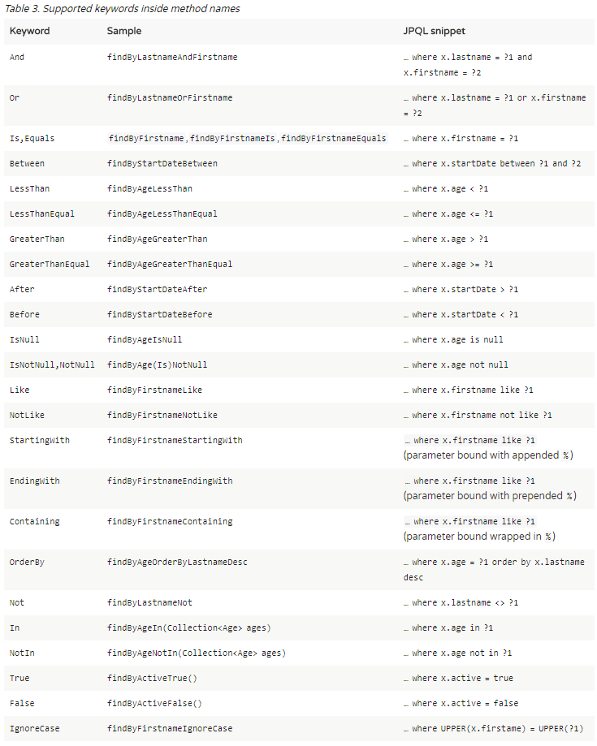

<https://docs.spring.io/spring-data/jpa/docs/current/reference/html/#repositories.query-methods.query-property-expressions>

// Enables the distinct flag for the query

List<Person> findDistinctPeopleByLastnameOrFirstname(String lastname, String firstname);

List<Person> findPeopleDistinctByLastnameOrFirstname(String lastname, String firstname);

findByLastnameAndFirstnameAllIgnoreCase(…)

List<Person> findByAddress_ZipCode(ZipCode zipCode);

*Example 17. Using Pageable, Slice, and Sort in query methods*

Page<User> findByLastname(String lastname, Pageable pageable);

Slice<User> findByLastname(String lastname, Pageable pageable);

List<User> findByLastname(String lastname, Sort sort);

List<User> findByLastname(String lastname, Pageable pageable);

*Example 18. Limiting the result size of a query with Top and First*

User findFirstByOrderByLastnameAsc();

User findTopByOrderByAgeDesc();

Page<User> queryFirst10ByLastname(String lastname, Pageable pageable);

Slice<User> findTop3ByLastname(String lastname, Pageable pageable);

List<User> findFirst10ByLastname(String lastname, Sort sort);

List<User> findTop10ByLastname(String lastname, Pageable pageable);